Misty Larsen
English 2710
Sec 042
Cub Scouts
Over the last couple years I have been helping with a group of boys between the ages of eight and eleven. This group of boys is known as a group of cub scouts. Folklore really came alive for me this semester as I worked with these boys. I found that Cub Scouts is a group full of material, verbal, and customary folklore all of which will be briefly touched upon.
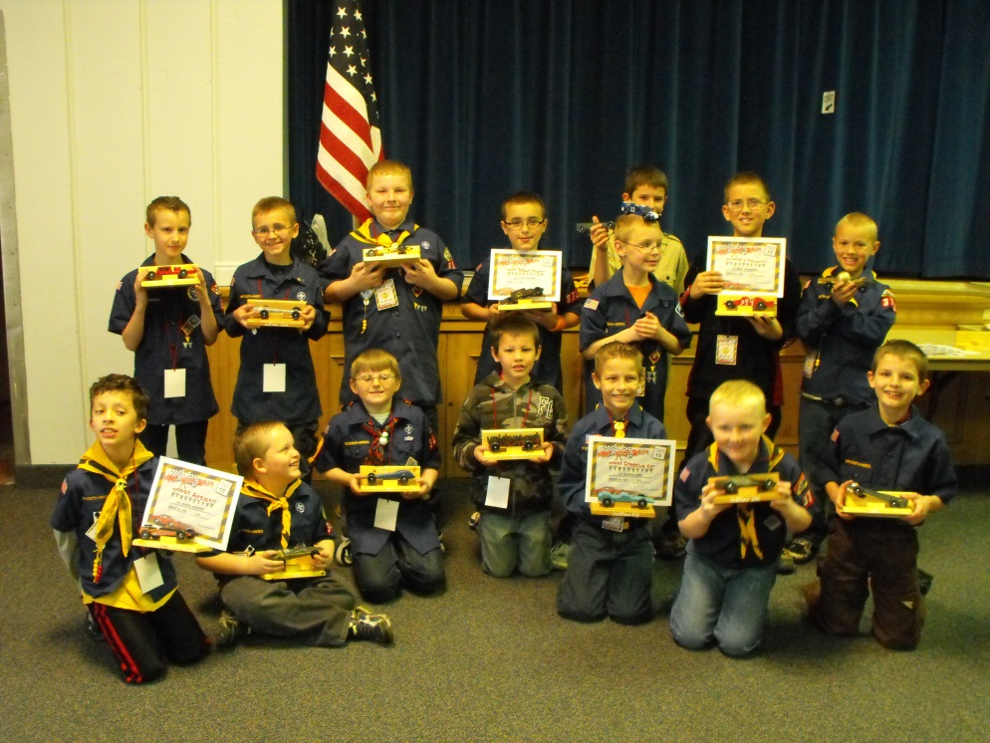
Martha C. Sims and Martine Stephens state in Living Folklore (2005), “Material folklore takes a number of different forms, some of it “permanent” such as architectural structures or functional tools, some of it ephemeral such as food, body painting, or paper ornaments. Permanent or not, material culture has in common that it is tangible – can be touched, seen, eaten or lived in.” One of the things that is easily distinguishable as belonging to the cub scouts is the uniform. The Cub Scout Bear Handbook states, “If you don’t wear your uniform to den and pack meetings, and on outings and special events, no one will be able to tell that you are a Cub Scout and that you have earned all the badges on your uniform shirt. Be proud to wear the Cub Scout uniform.” The uniform is an important part of distinguishing a Cub Scout and some ceremonies only allow boys to participate if they are wearing their uniform.
Figure 1 Cub Scout Pack
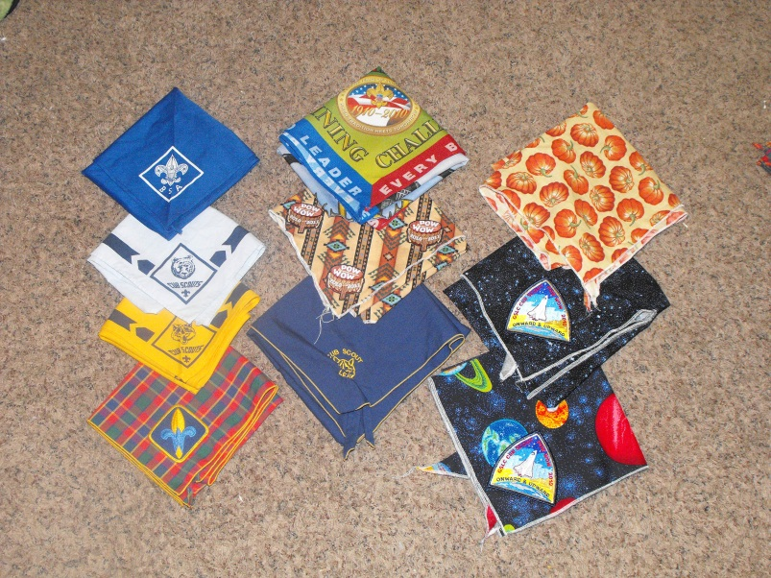
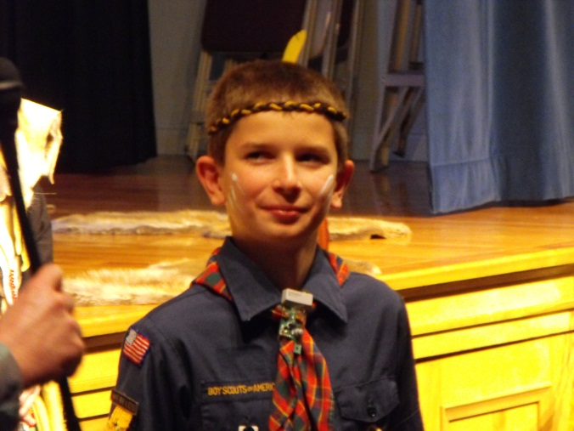
The uniform includes a blue shirt with “Boy Scouts of America” over the Right Pocket. It also has a flag at the top of the right sleeve. These are found on all cub scout uniforms and are easily recognized even by those not in the group. This group is so large that it is made up of many smaller groups known as packs. At the top of the left sleeve is a patch that shows which council, a group of packs located in the same geographic area, the cub scout belongs to and below that is a set of numbers that is unique to the pack the cub scout belongs to. These patches are unique to the Boy Scouts of America.
Figure 2 Collection of Neckerchiefs that includes both official and homemade neckerchiefs.
Figure 3 Cub Scout in Uniform
The uniform also includes a neckerchief. Neckerchiefs are used as a way of distinguishing members within the group and for games and other activities. There are usually three smaller groups within each pack known as dens each of which is distinguished with a different official Boy Scouts of America neckerchief, wolves wear yellow, bears wear blue, and webelos wear a checkered neckerchief. While most boys and leaders wear official neckerchiefs, neckerchiefs can also be made.
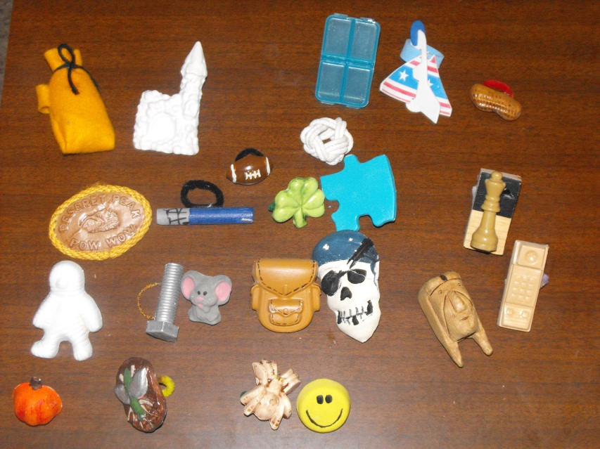
To keep the neckerchief in place the boys and leaders often use a neckerchief slide. There are some official neckerchief slides but it is really common to see a wide variety of homemade neckerchiefs. The boys will sometimes make these during activities or receive them as awards. Leaders, especially those who have been involved in the scouting program for a long time, often have large collections of neckerchief slides. These can be made from just about anything.
Figure 4 Collection of homemade neckerchief slides.
Another part of folklore is verbal folklore. Sims et.al (2005) states, “Verbal folklore includes any kind of lore involving words, whether set to music; organized in chronological, story form; or simply labeling an activity or expressing belief in a word or phrase.” There is a wide variety of verbal folklore within the cub scouts. Some of the verbal folklore of cub scouts has already been introduced in this paper.
Within the Cub Scouts there are certain words used to describe how the group is set up. A small group of boys working on the same rank is called a den. A group of dens is called a pack. A group of packs is called a district and a group of districts is called a council. All the councils in America make up the Boy Scouts of America. Not only is there language used to distinguish groups but also people within the group. A boy from the den who helps with the activities is called a denner. A boy scout who helps leaders is called a Den Chief. Parents and leaders can be referred to as “Akela”. The Cub Scout Wolf Handbook introduces Akela and states, “Like your parents or guardians, your teachers, and other adults who help you learn, Akela is your guide.”
Not only are there certain words that are used within the group but there are also stories that are used within the group. When a boy first comes into cub scouts he is introduced to the tale of Mowgli, a young boy who grew up in the jungle with animal friends to guide him along the way. Many people are familiar with the story of Mowgli because of Disney’s movie The Jungle Book. However as a boy advances within his pack more of the story of Mowgli is told. As a wolf Mowgli is accepted into the wolf pack and as a Bear Mowgli saves his friends.
Cub Scouts are also known for their unique cheers. This is often how the pack or den congratulates boys or leaders on accomplishments so rather than just clapping the pack uses various cheers. Each cheer has its own name. Leaders and boys can come up with these on their own but often they are shared as boys and leaders move and join new packs or at meetings leaders go to. Some recently given to leaders at a round table meeting, which is a training meeting for leaders, include:
- Pioneer Cheer: Divide in half: One side yells…Howdy, partner, the other side answers, Howdy friend…three times.
- Lone Ranger Cheer: Hi, Ho Silver, Away.
- Bear Hug: Put your arms around yourself and give yourself a big hug.
- Follow the Leader Cheer: When the right hand goes up…applaud. When the left hand goes up…cheer. When both hands go up…applaud and cheer.
- The Wave: Start at one end of the room, each section stands up and claps, the next section follows.
Another type of verbal folklore used when cub scouts get together is audience participation stories. These stories can be written by someone for a specific occasion or shared between leaders. Some are picked up from other groups that use them. The following is an audience participation story that I participated in at a monthly roundtable meeting.
How the Sun, Moon and Stars Got Into the Sky (Old Indian Legend)
Chief: stand with arms folded across chest and say “Ugh”
Sun: cover eyes with hands
Moon: frame face with hands and smile
Stars: blink rapidly
Long, long ago the Indians had no fire and no light. They suffered much during the cold of winter and they had to eat their food uncooked. They also had to live in darkness because there was no light. There was no SUN, no MOON, and no STARS in the sky. The great CHIEF kept them locked in a box. He took great pride in the fact that he alone had light. This great CHIEF had a beautiful daughter of whom he was also proud. She was much beloved by all the Indians in the tribe. In those days, the raven had the power of magic. He was a great friend of the Indians and the Indian CHIEF. He wondered how he might make life more comfortable for them. One day he saw the daughter of the CHIEF come down to the brook for a drink. He had an idea. He would put a magic spell on her. In time a son was born to the daughter of the CHIEF. The old CHIEF was delighted as the boy grew. His grandfather, the CHIEF became devoted to him. Anything that he wanted he could have.
One day he asked the CHIEF for the box containing the STARS. Reluctantly the old CHIEF gave it to him. The child played for a while by rolling the box around. Then he released the STARS and flung them into the sky. The Indians were delighted. This was some light…though not quite enough. After a few days, the child asked for the box containing the MOON. Again the CHIEF hesitated, but finally, the boy got what he had asked for. Again, after playing a while with the toy, the boy released the MOON and flung it into the sky. The tribe was overjoyed. But still there was not enough light and the MOON disappeared for long periods.
Finally, the boy asked for the box with the SUN. “No”, said the old chief. “I cannot give you that.” But the boy wept and pleaded. The old CHIEF could not stand the tears, so he gave him the box. As soon as he had a chance, the child released the SUN and cast it up in the sky. The joy of the Indians knew no bounds. Here was light enough and heat as well. They ordered a feast of the SUN and all of the Indians celebrated it with great jubilation. And the old CHIEF was happy. He had not known that the SUN and the MOON and the STARS could mean so much for the happiness of his people. And for the first time, he too, enjoyed himself.
Audience participation stories such as these bring the audience, which is usually made up of family members, leaders, and cub scouts, together.
The last aspect of folklore is customary folklore. Sims et al. (2005) states, “A custom is a repeated habitual action, a usual way of doing something. For folklorists, custom refers to patterned, repeated behavior in which a person’s participation indicates involved membership. These practices may be situations that are stylized and or “framed” by special words, gestures, or actions that set them apart from everyday behaviors or they may be as simple as gestures used in everyday communication within an intimate group of friends.” Customary folklore often includes verbal and nonverbal folklore.
One simple example of customary folklore is when a leader wants everyone to quiet down. This is done by the leader raising the Cub Scout sign high in the air and holding it there till everyone stops talking. The Cub Scout sign is simply two fingers lifted high in the air. The Cub Scout Wolf Handbook states, “They (the fingers) look like a wolf’s ears; this means you are ready to listen to Akela.”
Ceremonies are great examples of customary folklore. Cub Scouting is full of ceremonies. There are opening ceremonies, closing ceremonies, flag ceremonies, award ceremonies, and rank advancement ceremonies. Ceremonies can be simple or they can be very elaborately planned out.
A flag ceremony often starts a cub scout meeting. There can be as many flags involved as desired. In order to participate in this ceremony the boys have to be in uniform. It always involves at least one person saying something that has been prepared beforehand. These ceremonies can be simple to extravagant and in our group they culminate with the Pledge of Allegiance.
Another ceremony that cub scouts have is a rank advancement ceremony. These also range from simple to very elaborate. One of the biggest accomplishments for a Cub Scout is to earn their Arrow of Light which is the highest rank in Cub Scouting. For this particular award we bring in a group that has prepared a ceremony specifically for awarding this to the boys. The group we bring in has costumes, furs, and blankets. They often present an arrow to the boy who earned this award. This group has a script they have put together that describes the importance of what the boy has done to receive this award. Everything combined makes a spectacular rank advancement ceremony that serves to peak younger boys interest in continuing in scouting and earning this award.
Figure 5 Arrow of Light Recipient and Presenters after ceremony
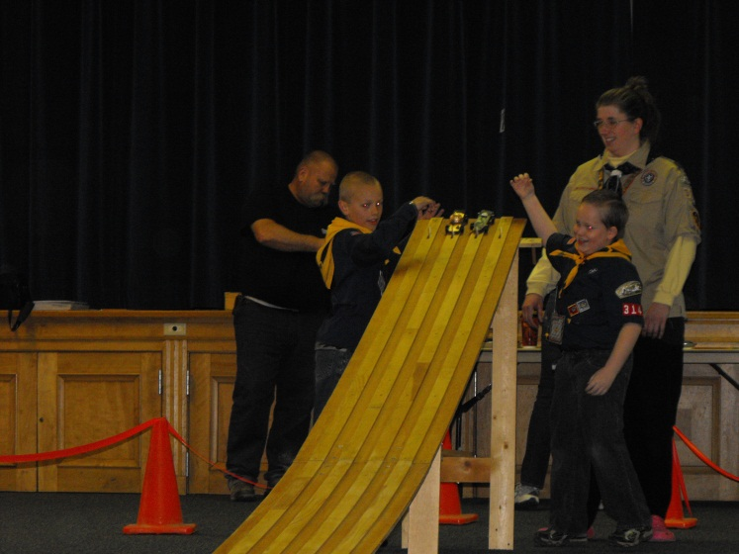
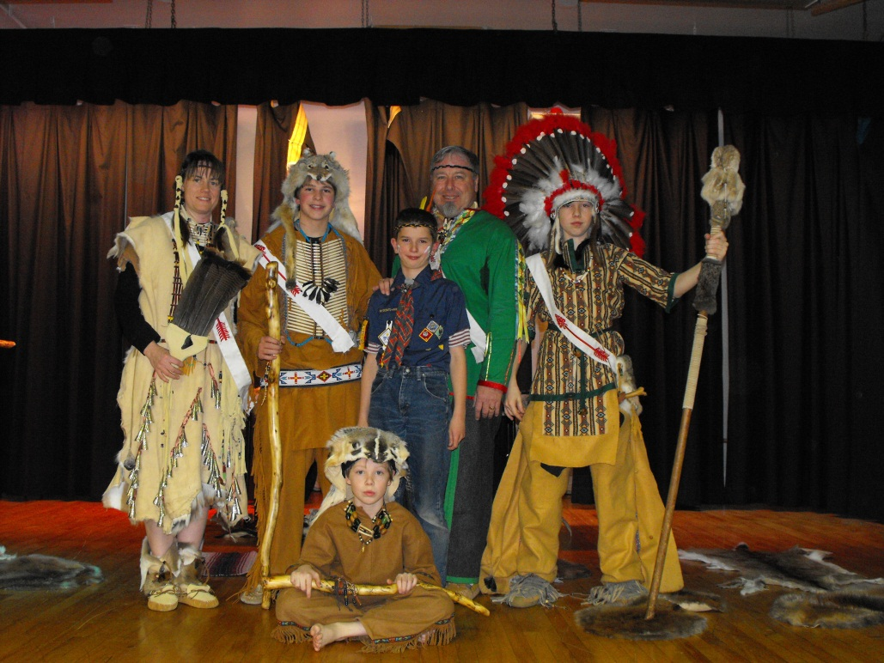
Another example of customary folklore within cub scouts is the Pinewood Derby. The pinewood derby is an annual event where the boys are given a block of wood to build a car out of. Usually the boys get help from their parents or grandparents in building it. Each year the boys get to build a new car. On a specified day each car is weighed and prepared for a race. A race track is also set up. Once a process of elimination is established the boys are able to race their cars until eventually a winner is reached. Then after the race has ended and the winners have been determined various awards are given out.
Figure 6 Pinewood derby race
Cub Scouts is a folk group that is full of material, verbal, and customary folklore. The examples in this paper are just a few examples of each genre of folklore found within the Cub Scouts.

Works Cited
Boy Scouts of America. Cub Scout Bear Handbook. Boy Scouts of America, 2003.
—. Cub Scout Wolf Handbook. Boy Scouts of America, 2003.
Jonathan Meacham, Adam Mauchley. "http://www.deseretpeakcubscouting.com/resources/March%202012%20Cubmaster%20Handout.pdf." March 2012. www.deseretpeakcubscouting.com. 24 April 2012.
Martha G. Sims, Martine Stephens. Living Folklore. Logan, UT: Utah State University Press, 2005.

